**DAILY ONLINE ACTIVITIES SUMMARY**

|  |  |  |  |  |  |  |  |  |  |  |
| --- | --- | --- | --- | --- | --- | --- | --- | --- | --- | --- |
| **Date:** |  | **3/06/2020** | | |  |  |  | **Name:** | **Suhas Prasad Shetty** | |
|  |  |  |  |  |  |  |  |  |  |  |
| **Sem & Sec** |  | **8th- B** | | |  |  |  | **USN:** | **4AL16CS080** | |
|  |  |  |  |  |  |  |  |  |  |  |
|  |  |  |  |  |  | **Online Test** | | **Summary** |  |  |
|  | |  |  |  |  |  |  |  |  |  |
| **Subject** | |  | **-** |  |  |  |  |  |  |  |
|  | |  |  |  |  |  |  | |  |  |
| **Max. Marks** | |  | **-** |  |  |  | **Score** | | **-** |  |
|  |  |  |  |  |  | |  | |  |  |
|  |  |  |  |  | **Certification Course Summary** | | | | | |
|  | |  | |  | | | | |  |  |
| **Course** |  | **Getting into the serverless Mindset** | | | | | | |  |  |
|  |  | | |  |  |  |  | |  |  |
| **Certificate Provider** | | | |  | **Aws** |  | **Duration** | |  | **30Mins** |
|  |  |  |  |  |  |  |  | |  |  |
|  |  |  |  |  |  | **Coding Challenges** | | |  |  |

**Problem Statement:**

**1) To print the pattern of the following form containing the numbers Sample Input 0**

**2**

**Sample Output 0**

**2 2 2**

**2 1 2**

**2 2 2**

**Status: Executed**

|  |  |
| --- | --- |
| **Uploaded the report in Github** | **Yes** |
|  |  |
| **If yes Repository name** | **Suhas** |
|  |  |
| **Uploaded the report in slack** | **Yes** |

**Certification Course Details:**

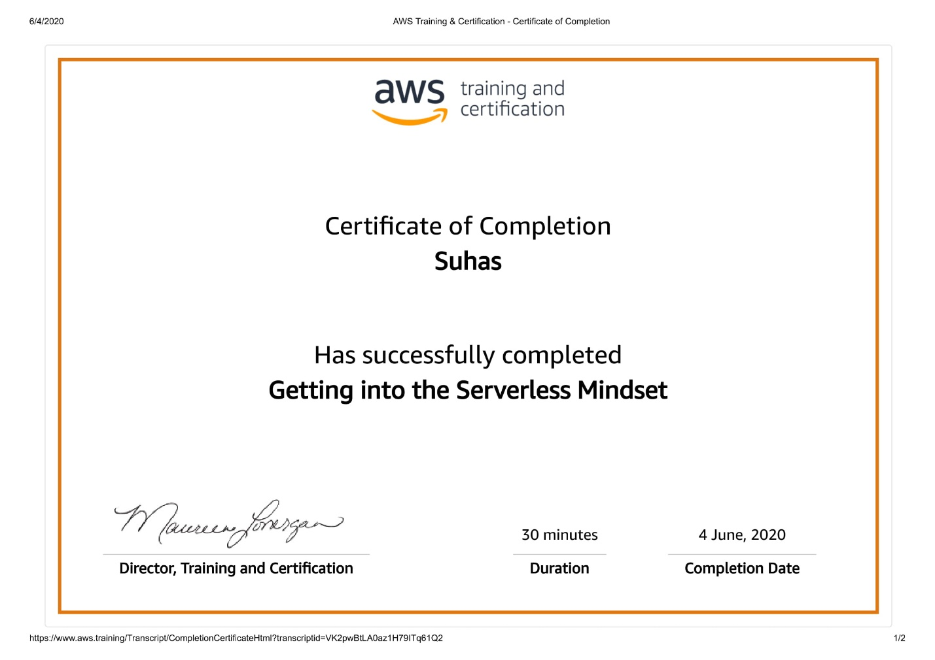

**Coding Challenges Details:**

**#include <stdio.h>**

**int main()**

**{**

**int n;**

**scanf("%d", &n);**

**int len = n*2 - 1;**

**for(int i=0;i<len;i++){**

**for(int j=0;j<len;j++){**

**int min = i < j ? i : j;**

**min = min < len-i ? min : len-i-1;**

**min = min < len-j-1 ? min : len-j-1;**

**printf("%d ", n-min);**

**}**

**printf("\n");**

**}**

**return 0;**

**}**